**Note- All commands to be executed on different cmd windows**

Step1 (cmd window 1)

* Go to your Kafka installation directory: *For me, it’s C:\kafka\bin\windows.*
* Open a command prompt and run the following command. To create topic

**kafka-topics.bat --create --zookeeper localhost:2181 -replication-factor 1**

**--partitions 1 --topic chat-message**

Step2(cmd window2)

Go to kafka folder in c: drive open cmd window1 for zookeeper in that folder and run below command

**.\bin\windows\zookeeper-server-start.bat .\config\zookeeper.properties**

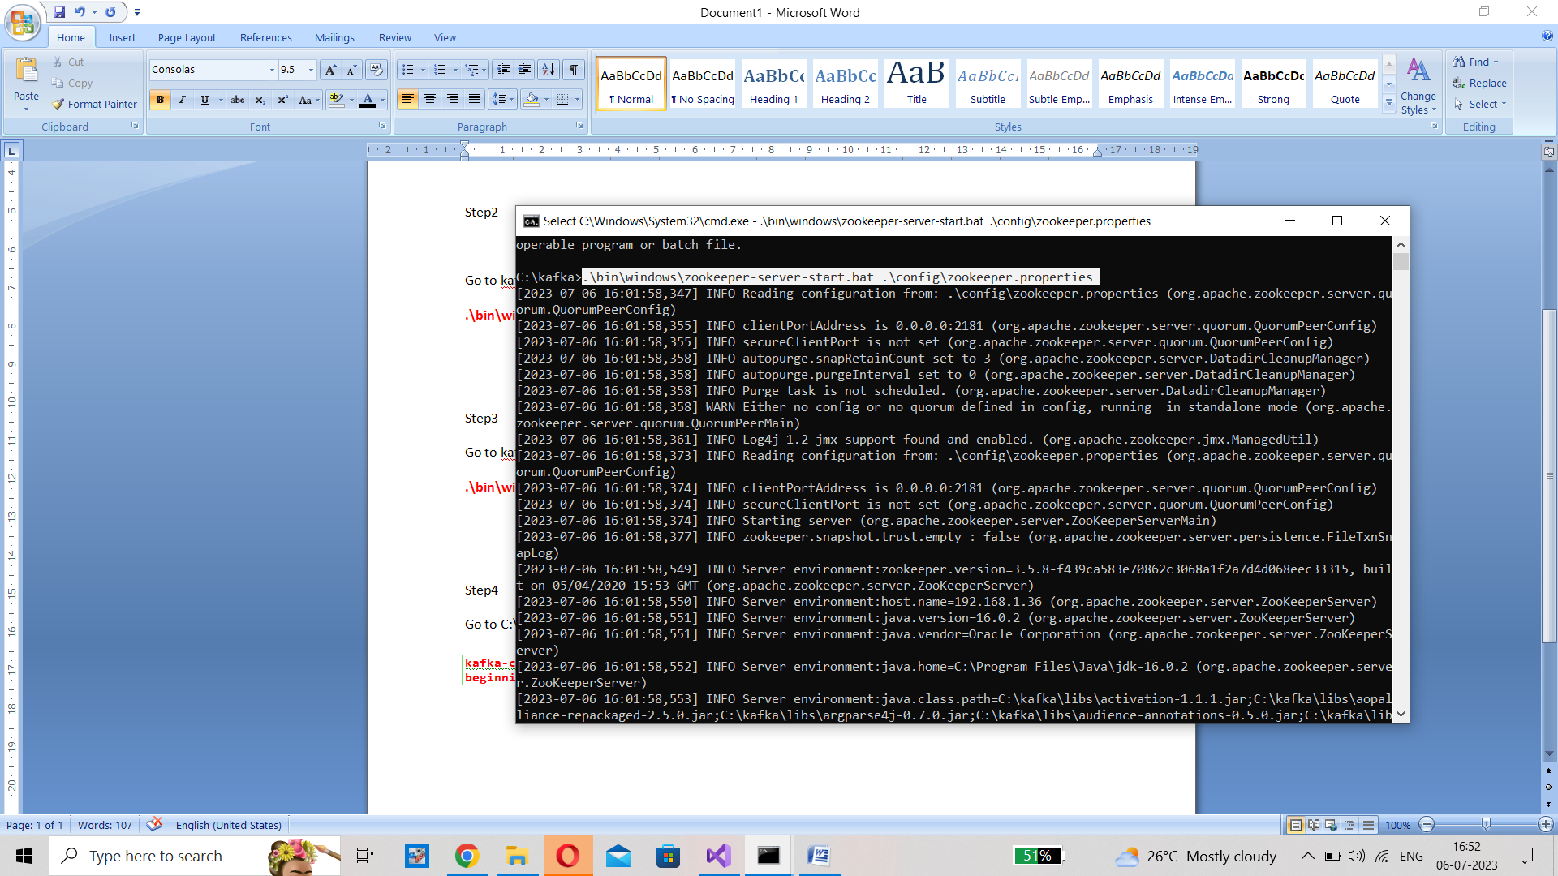

Step3(cmd window 3)

Go to kafka folder in c: drive open cmd window2 for server in that folder and run below command

**.\bin\windows\kafka-server-start.bat .\config\server.properties**

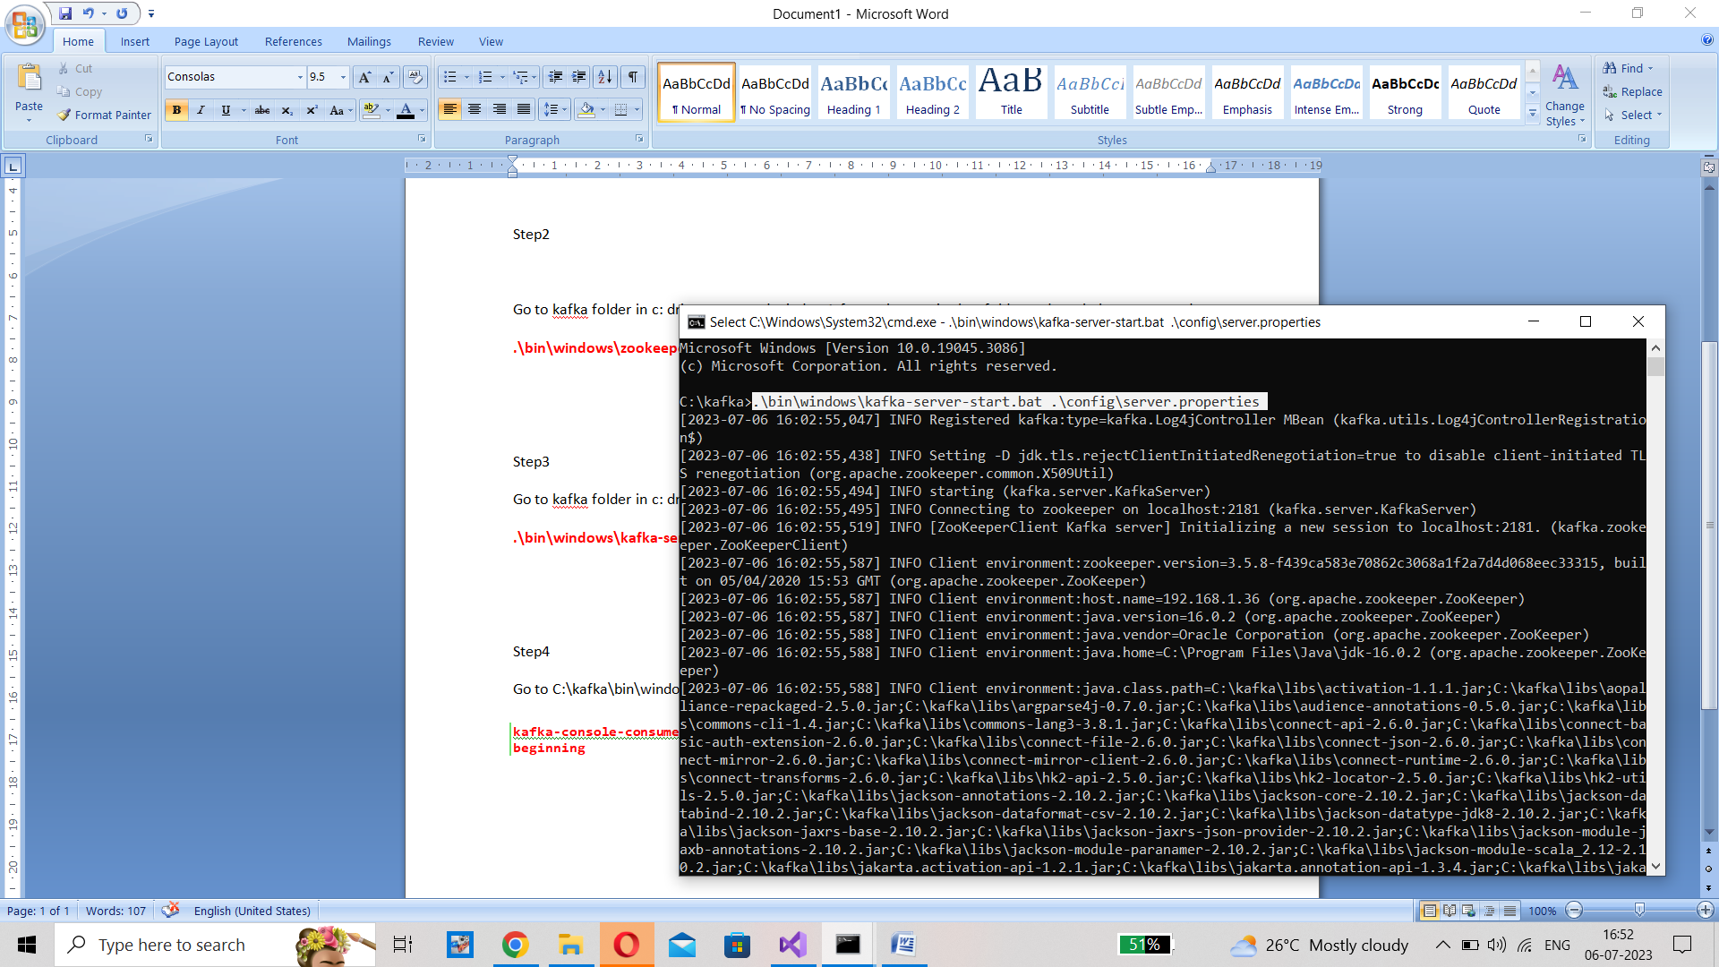

Step4 (cmd window4)

Go to C:\kafka\bin\windows and open cmd window and open consumer to receive the messages

**kafka-console-consumer.bat --bootstrap-server localhost:9092 --topic chat-message --from-beginning**

